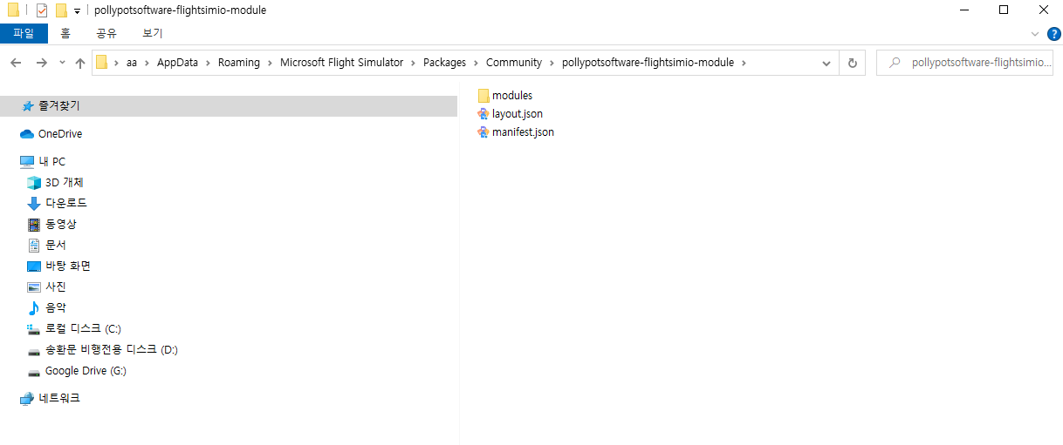

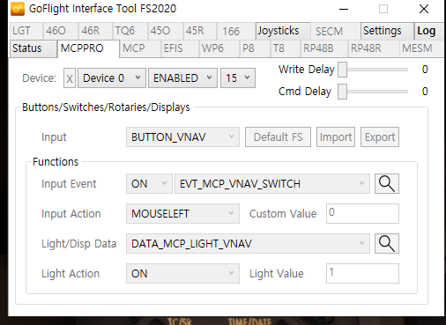

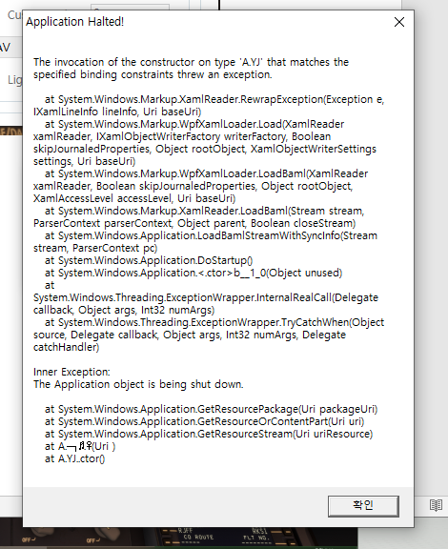

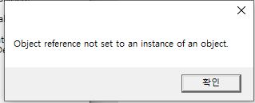

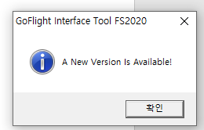

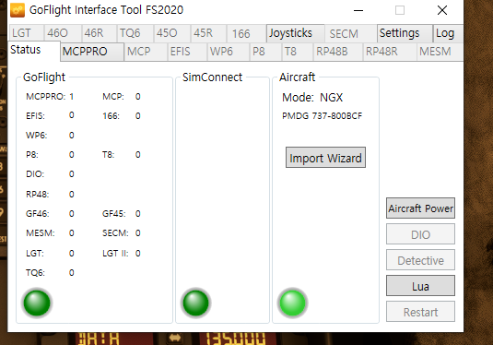

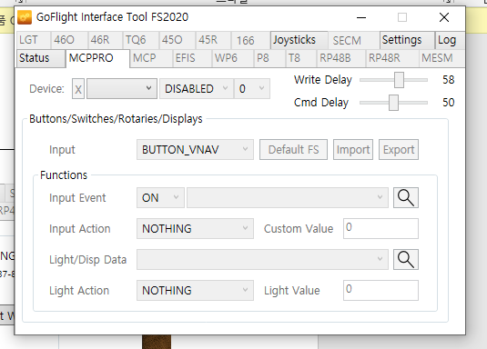

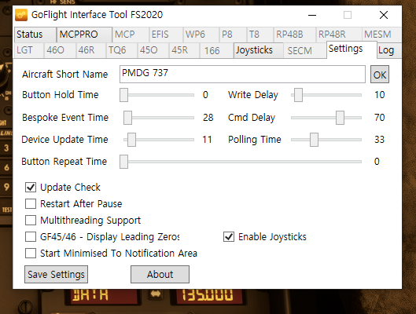

06:52:27 GoFlight Connection Starting.....

06:52:27 SimConnect Connection Starting.....

06:52:27 GoFlight Connection Started

06:58:47 SimConnect Message Processing Started

06:58:47 SimConnect Connection Started

06:58:47 Aircraft Connection Starting.....

06:58:48 WinSock: Connected To 127.0.0.1 On Port 27016!

06:58:48 LUA Processor: Started!

06:58:48 Aircraft Connection Started

06:58:48 Simconnect Version: 11.0.62651.3

06:58:48 Aircraft FullName: Generic

06:58:58 SimConnect: Event Received: Start

06:58:58 SimConnect Receive Message Exception: startIndex는 문자열의 길이보다 클 수 없습니다.

매개 변수 이름: startIndex

06:59:26 SimConnect: Event Received: SIMSTOP, 0

06:59:26 SimConnect: Event Received: SIM, 0

06:59:27 PMDG SDK option is OK in FS2020

06:59:27 SimConnect: Event Received: Aircraft Type Changed

06:59:27 GoFlight Connection Starting.....

06:59:27 SimConnect Message Processing Finished

06:59:27 Synchronising Switches & Selectors .....

06:59:27 Synchronising Switches & Selectors: Waiting for SimConnect .....

06:59:27 SimConnect Connection Starting.....

06:59:28 Creating Bespoke Vars

06:59:28 Bespoke Vars Created

06:59:28 Importing Bespoke Variables

06:59:28 Bespoke Vars Assigned, Importing Bespoke Events

06:59:28 Bespoke Events Temp Imported

06:59:28 Bespoke Events Imported

06:59:28 Joystick Device Found: Logitech Extreme 3D

06:59:28 Joystick Device Found: T-Rudder

06:59:28 Device Found: USB Keyboard

06:59:28 Device Found: MCP Pro

06:59:28 SimConnect Message Processing Started

06:59:28 Mouse Device Found: 마우스

06:59:28 Keyboard Device Found: 키보드

06:59:28 Joystick Found Device 0: Logitech Extreme 3D

06:59:28 Device 0 Button Count: 12

06:59:28 Device 0 POV Count:1

06:59:28 Joystick Found Device 1: T-Rudder

06:59:28 Device 1 Button Count: 0

06:59:28 Device 1 POV Count:0

06:59:28 SimConnect Connection Started

06:59:28 Aircraft Connection Starting.....

06:59:28 SimConnect: Event Received: Aircraft Loaded/Flight Loaded

06:59:28 SimConnect: Event Received: SIM, 1

06:59:28 SimConnect: Event Received: PAUSE, 1

06:59:29 GoFlight Connection Started

06:59:30 WinSock: Connected To 127.0.0.1 On Port 27016!

06:59:30 LUA Processor: Started!

06:59:30 Aircraft Connection Started

06:59:30 Simconnect Version: 11.0.62651.3

06:59:30 Aircraft FullName: PMDG 737-800BCF

06:59:59 SimConnect: Exception Received: OUT_OF_BOUNDS

06:59:59 SimConnect: Exception Received: ILLEGAL_OPERATION

06:59:59 Global LUA Event Running

06:59:59 Global Aircraft LUA Event Running

06:59:59 Synchronising Switches & Selectors Complete

07:00:38 SimConnect: Event Received: Aircraft Loaded/Flight Loaded

07:00:39 SimConnect: Event Received: SIMSTOP, 0

07:00:39 SimConnect: Event Received: SIM, 0

07:00:39 SimConnect: Event Received: SIMSTART, 0

07:00:39 SimConnect: Event Received: SIM, 1

07:00:42 SimConnect: Event Received: SIMSTOP, 0

07:00:42 SimConnect: Event Received: SIM, 0

07:00:42 SimConnect: Event Received: Aircraft Loaded/Flight Loaded

07:00:42 SimConnect: Event Received: Aircraft Loaded/Flight Loaded

07:00:44 SimConnect: Event Received: SIMSTART, 0

07:00:44 SimConnect: Event Received: SIM, 1

07:01:56 Send Control Data: Too Many Retries

07:01:56 Send Control Data: Too Many Retries

07:01:57 Send Control Data: Too Many Retries

07:01:57 Send Control Data: Too Many Retries

07:01:58 Send Control Data: Too Many Retries

07:01:58 Send Control Data: Too Many Retries

07:01:58 Send Control Data: Too Many Retries

07:01:59 Send Control Data: Too Many Retries

07:01:59 Send Control Data: Too Many Retries

07:02:00 Send Control Data: Too Many Retries

07:02:00 Send Control Data: Too Many Retries

07:02:00 Send Control Data: Too Many Retries

07:02:01 Send Control Data: Too Many Retries

07:02:01 Send Control Data: Too Many Retries

07:02:02 Send Control Data: Too Many Retries

07:02:02 Send Control Data: Too Many Retries

07:02:02 Send Control Data: Too Many Retries

07:02:03 Send Control Data: Too Many Retries

07:02:03 Send Control Data: Too Many Retries

07:02:04 Send Control Data: Too Many Retries

07:02:04 Send Control Data: Too Many Retries

07:02:04 Send Control Data: Too Many Retries

07:02:05 Send Control Data: Too Many Retries

07:02:05 Send Control Data: Too Many Retries

07:02:08 Send Control Data: Too Many Retries

07:02:08 Send Control Data: Too Many Retries

07:02:09 Send Control Data: Too Many Retries

07:02:09 Send Control Data: Too Many Retries

07:02:10 Send Control Data: Too Many Retries

07:02:10 Send Control Data: Too Many Retries

07:02:10 Send Control Data: Too Many Retries

07:04:00 Send Control Data: Too Many Retries

07:04:01 Send Control Data: Too Many Retries

07:04:01 Send Control Data: Too Many Retries

07:06:47 Send Control Data: Too Many Retries

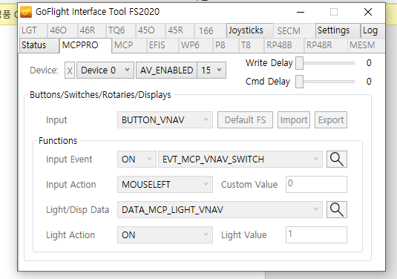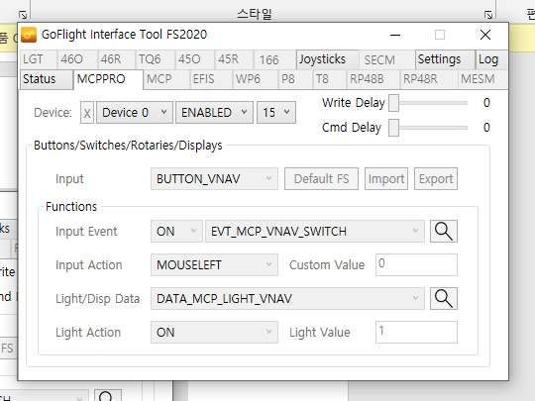

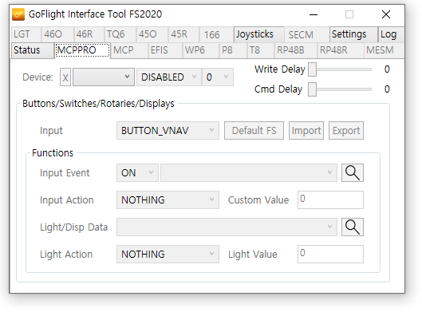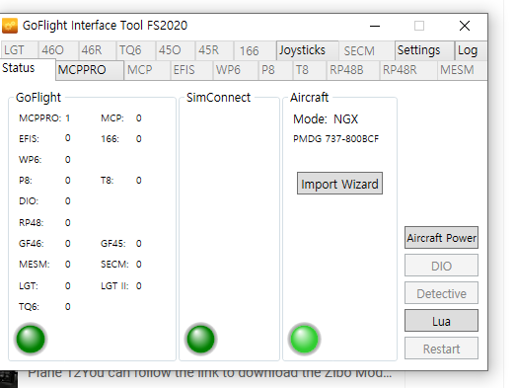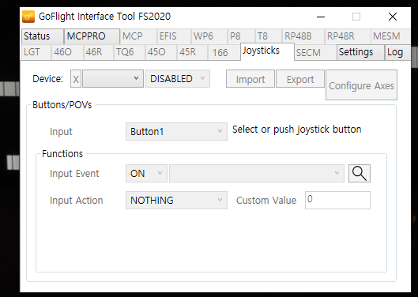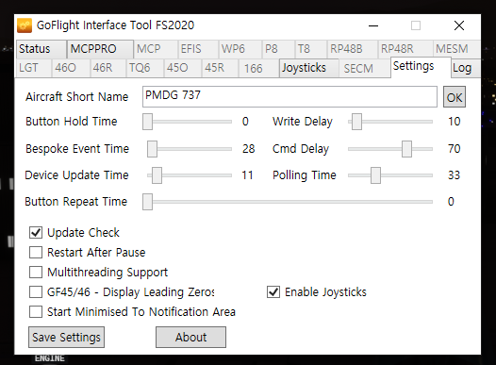

05:53:51 GoFlight Connection Starting.....

05:53:51 SimConnect Connection Starting.....

05:53:51 SimConnect Message Processing Started

05:53:51 PMDG SDK option is OK in FS2020

05:53:51 SimConnect: Event Received: Aircraft Type Changed

05:53:51 SimConnect: Event Received: SIM, 1

05:53:51 SimConnect: Event Received: PAUSE, 1

05:53:51 GoFlight Connection Started

05:53:51 SimConnect Connection Started

05:53:51 Aircraft Connection Starting.....

05:53:51 GoFlight Connection Starting.....

05:53:51 SimConnect Message Processing Finished

05:53:51 Aircraft Connection Starting.....

05:53:52 SimConnect Connection Starting.....

05:53:52 Creating Bespoke Vars

05:53:52 Bespoke Vars Created

05:53:52 Importing Bespoke Variables

05:53:52 Bespoke Vars Assigned, Importing Bespoke Events

05:53:52 Bespoke Events Temp Imported

05:53:52 Aircraft Processor: SubscribeToSimObjectEvent Failed

05:53:52 Bespoke Events Imported

05:53:52 Joystick Device Found: Logitech Extreme 3D

05:53:52 Joystick Device Found: T-Rudder

05:53:53 Device Found: USB Keyboard

05:53:53 Device Found: MCP Pro

05:53:53 Aircraft Processor: SubscribeToSimObjectEvent Failed

05:53:53 SimConnect Message Processing Started

05:53:53 Mouse Device Found: 마우스

05:53:53 Keyboard Device Found: 키보드

05:53:53 Joystick Found Device 0: Logitech Extreme 3D

05:53:53 Device 0 Button Count: 12

05:53:53 Device 0 POV Count:1

05:53:53 Joystick Found Device 1: T-Rudder

05:53:53 Device 1 Button Count: 0

05:53:53 Device 1 POV Count:0

05:53:53 SimConnect Connection Started

05:53:53 SimConnect: Event Received: Aircraft Loaded/Flight Loaded

05:53:53 SimConnect: Event Received: SIM, 1

05:53:53 SimConnect: Event Received: PAUSE, 1

05:53:53 SimConnect: Exception Received: UNRECOGNIZED_ID

05:53:53 SimConnect: Exception Received: DUPLICATE_ID

05:53:53 SimConnect: Exception Received: DUPLICATE_ID

05:53:54 GoFlight Connection Started

05:53:54 SimConnect: Exception Received: DUPLICATE_ID

05:53:54 SimConnect: Exception Received: DUPLICATE_ID

05:53:54 SimConnect: Exception Received: DUPLICATE_ID

05:53:54 SimConnect: Exception Received: DUPLICATE_ID

05:53:56 WinSock: Connection Failed: 대상 컴퓨터에서 연결을 거부했으므로 연결하지 못했습니다 127.0.0.1:27016

05:53:56 LUA Processor: Connect Exception - Unable To Connect!

05:53:56 Aircraft Connection Started

05:53:56 Simconnect Version: 11.0.62651.3

05:53:56 Aircraft FullName: PMDG 737-800BCF

05:53:56 WinSock: Connection Failed: 대상 컴퓨터에서 연결을 거부했으므로 연결하지 못했습니다 127.0.0.1:27016

05:53:56 LUA Processor: Connect Exception - Unable To Connect!

